**Day 11/40 - Multi Container Pod Kubernetes**

<https://linchpiner.github.io/k8s-multi-container-pods.html>

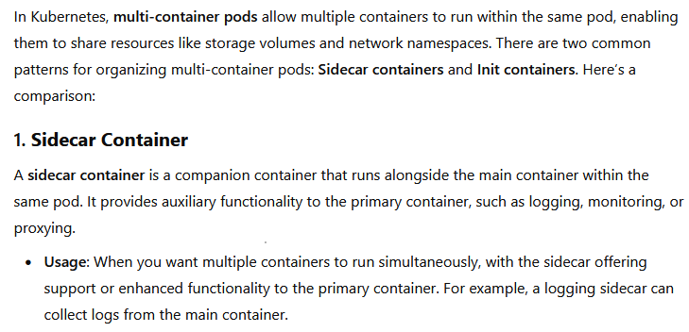

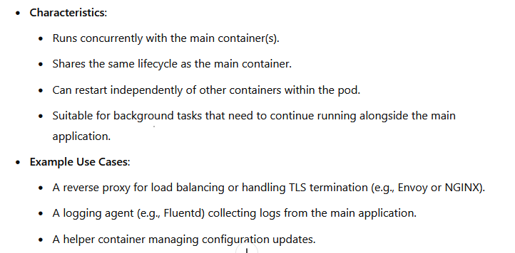

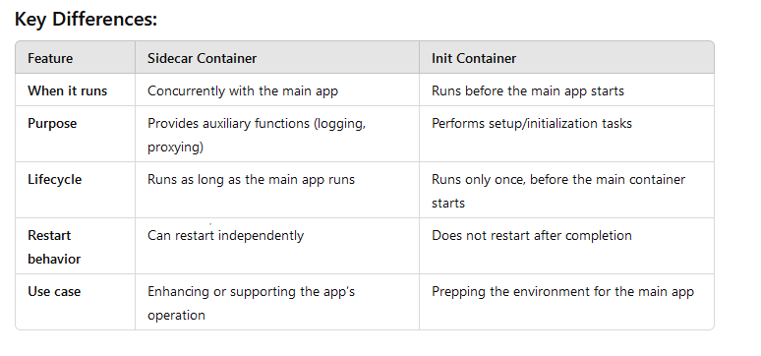

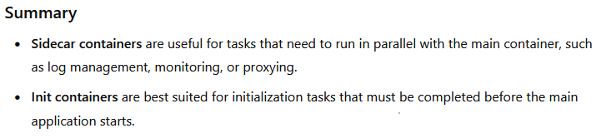

vim 8.yaml

apiVersion: v1

kind: Pod

metadata:

name: myapp-pod

labels:

app.kubernetes.io/name: MyApp

spec:

containers:

- name: myapp-container

image: busybox:1.28

env:

- name: FIRSTNAME

value: "Piyush"

command: ['sh', '-c', 'echo The app is running! && sleep 3600']

initContainers:

- name: init-myservice

image: busybox:1.28

command: ['sh', '-c']

args: ['until nslookup myservice.default.svc.cluster.local; do echo waiting for myservice; sleep 2; done']

- name: init-mydb

image: busybox:1.28

command: ['sh', '-c']

args: ['until nslookup mydb.default.svc.cluster.local; do echo waiting for mydb; sleep 2; done']

#k create -f 8.yaml

K get pods

#k logs myapp-pod



#k logs myapp-pod -c init-myservice

#k create deploy nginx-deploy --image nginx --port 80

#k get deploy

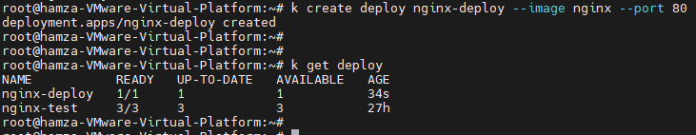

#k expose deploy nginx-deploy --name myservice --port 80

k logs myapp-pod -c init-myservice

19 min

k exec -it myapp-pod -- printenv